 WINGROVE PRIMARY SCHOOL 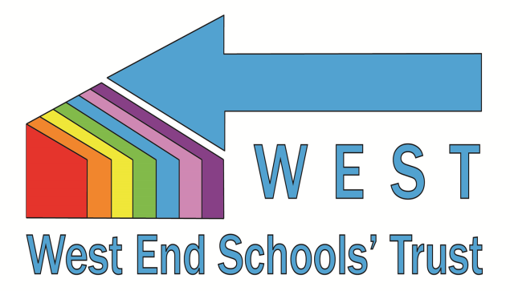
Hadrian Road
Newcastle NE4 9HN
0191 2735466
www.wingrove.newcastle.sch.uk

Administrative Assistant, Level 3

Salary range: N4 £25,584 to £26,409 per annum pro rata (Actual £21,055 to £21,655 pa)

35 hours per week, term time plus 5 training days

The Governing Body of Wingrove Primary School wish to appoint an Administrative Assistant to work alongside the School Business Manager and Finance and Office Manager. Previous experience of administrative work, particularly in a school setting, is desirable although not essential as training will be given. You should have excellent inter-personal skills and the ability to represent the school in the role of ‘front of house’. You should be able to use your own initiative, organise your time and prioritise tasks.

Wingrove is a large primary school serving a vibrant and diverse population in Newcastle’s west end. We are two-form entry, from Nursery to Year 6 (472 pupils). We have extensive grounds, including a football pitch, MUGA, cycle track, forest school (including round-house and dunny) and allotment. Our school is highly valued and supported by parents and the community. We are a popular school with a lengthy waiting list. Our pupils are well-behaved and happy and are enthusiastic to learn. We can offer you commitment to your own professional development. You will join a team of support staff who work together to improve practice and outcomes for our children.

We are part of the West End Schools’ Trust (WEST). The Trust strengthens the schools’ co-operative work and encourages collaborative work with identified key partners to further improve standards and enhance opportunities for children, parents, staff and the wider community. It is responsible for the education of around two thousand and seven hundred children and employs over four hundred teachers, teaching assistants and administrative staff.

This post is offered as 35 hours per week, term time only, to be worked 0830-1545 M/T/Th/F and 0830-1700 each Wednesday (staff training).

We are strongly committed to safeguarding and promoting the welfare of children and young people. The successful applicant will be required to undergo a range of recruitment checks and to obtain an Enhanced Certificate of Disclosure from the DBS.

Application packs can be obtained from our website, or by contacting the school office. Completed applications should be marked for the attention of the School Business Manager, Mrs. Debra Lowdon. They should be typed and accompanied by a handwritten letter, and can be posted, handed in at the school office, or emailed to admin@wingrove.newcastle.sch.uk.

Informal visits to school are encouraged and can be accommodated outside of office hours. Please telephone Mrs. Nahila Mirza to make an appointment 0191 2735466 / 2735842.

Closing date for applications: Friday 20th June at 1200 hours.

