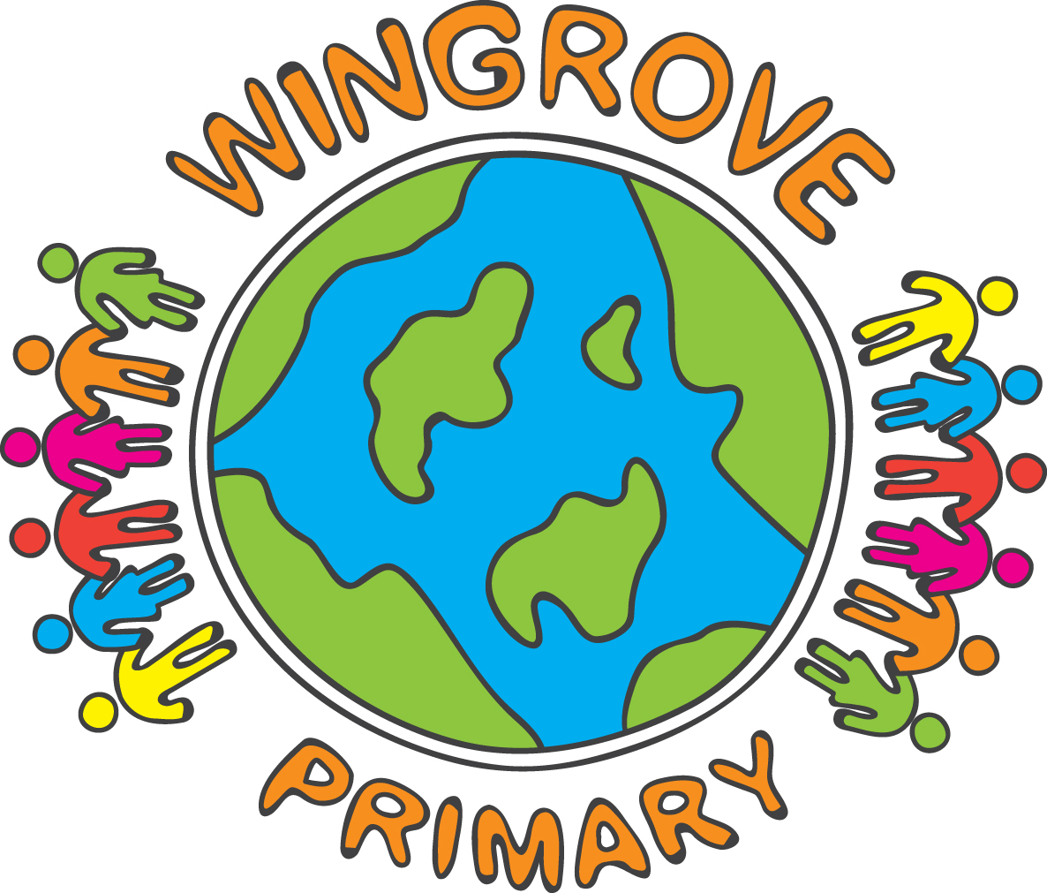

WINGROVE PRIMARY SCHOOL

Operating a halal kitchen

Christmas Lunch
Thursday 12th December

Roast Chicken Breast or
Roast Quorn Fillet

With

Chicken or Vegetarian Sausage
Stuffing and gravy
Brussels Sprouts, Carrots and Sweetcorn
Roast Potatoes

Dessert
Vanilla Ice Cream with Mandarins
Or
Seasonal Festive Biscuit
Or
Fruit

Mrs Mullarkey is kindly offering this free of charge to all pupils. It is assumed that all children in years 3, 4, 5 and 6 will be having a Christmas lunch.
However, in order to reduce food waste, please let us know, by Monday 2nd December 2024, if you intend to provide your child with a packed lunch.

Thank you.



