 WINGROVE PRIMARY SCHOOL 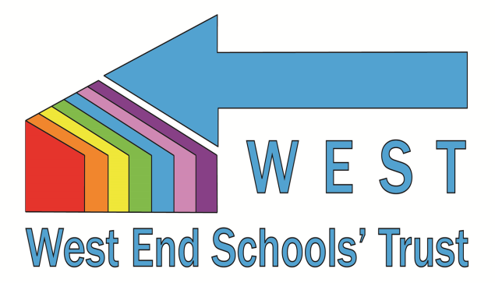
Part of the West End Schools’ Trust

Job Description: Class Teacher

Post Title: | Class Teacher
Pay Scale: | Main / Upper Pay Spine
Responsible to: | KS Co-ordinator and / or Head Teacher
Job Purpose: | To be accountable for the educational progress of learners by delivering effective teaching and providing effective learning opportunities.  To contribute to the effective observation, monitoring and assessment of pupils

Main responsibilities:

The following list is typical of the level of duties which the post holder will be expected to perform. It is not necessarily exhaustive and other duties of a similar type and level may be required from time to time.

General
To carry out the professional duties of a Teacher as set out in the School Teachers' Pay and Conditions Document. Carry out teaching duties in accordance with the school's schemes of work and the National Curriculum.
Generic Responsibilities

- Establish a purposeful and safe learning environment and manage learners’ behaviour constructively by establishing and maintaining a clear and positive framework for discipline and a supportive culture in line with the school behaviour policy.

- Contribute, as part of the team, to the effectiveness of the curriculum and its assessment to ensure suitable opportunities are provided for learner aspirations to be met.

- Plan effectively in the short, medium and long-term and prepare effective learning sequences, lessons and work across a series of lessons to ensure coverage of the curriculum and the differentiated needs of learners are met. Plan, prepare and assess tasks which enable parents to support their children’s learning.

- Understand EYFS teaching and learning strategies and continue to apply, extend and develop them within the National Curriculum. Implement inclusive practices, to ensure that the diverse needs of learners are met and excellence and enjoyment is achieved. Deliver lessons to groups of learners or classes. Demonstrate the positive values, attitudes and behaviour expected from learners, and to promote the positive ethos of the school.

- Assess, record and report on the development and progress of learners and analyse relevant data to promote the highest possible aspirations for learners and target expectations and actions to raise learners’ achievements. Provide timely, accurate and constructive feedback on learners’ attainment, progress and areas for development.

- Demonstrate ongoing development and application of teaching practice, expertise and subject, specialism and/or phase knowledge to enrich the learning experience within and beyond the teacher’s assigned classes or groups of learners.

- Communicate effectively and work collaboratively within and beyond the classroom with support staff (including directing their day-to-day work), teachers, other professionals, parents, carers, agencies and communities, to enhance teaching and learning and promote the positive contribution and well-being of learners.

- Contribute to the development and implementation of Wingrove’s priorities, policies and activities in order to enable the achievement of whole school aims.

- Promote the safeguarding and welfare of children and young persons for whom the post holder is responsible, or comes into contact with. Be aware of school policies and other guidance on the safeguarding and the promotion of wellbeing of children and young people. Take appropriate action where required.

- To work effectively with / be aware of and assist integrated processes, such as Common Assessment Framework and local opportunities which support ECM and NCYPP aims for children, young people and their families

- Promote and implement policies and practices that encourage mutual tolerance and respect for diversity in all aspects of employment and service delivery.

In addition, Upper Pay Spine teachers are expected to:

- Make significant contributions to implementing workplace policies and practice and to promote their implementation.

- Give advice on the development and wellbeing of children and young people, if required.

- Promote collaboration between colleagues and contribute to their professional development through coaching and mentoring, demonstrating effective practice, and providing advice and feedback.

