**JESMOND PARK ACADEMY YEAR 6 TRANSITION**

**IMPORTANT EVENTS INFORMATION**

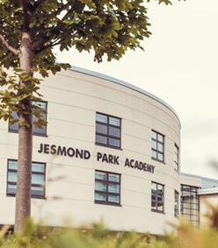**Year 6 Parent/Carer Evening**

|  |  |
| --- | --- |
| **Tuesday 18 June 2024** | |
| **There will be two sessions; please choose ONE session to attend** |  |
| **4:30pm – 5:00pm**  (arrive from 4:20pm) |
| **6:00pm – 6:30pm**  (arrive from 5:50pm) |

As a parent/carer, you will be welcomed to the school by our Principal, Mr Campbell. You have the opportunity to listen to key staff who will explain how we help our new Year 7 students successfully join our learning community at Jesmond Park Academy. **The evening is intended just for parents/carers**.

**Year 6 Transition Days**

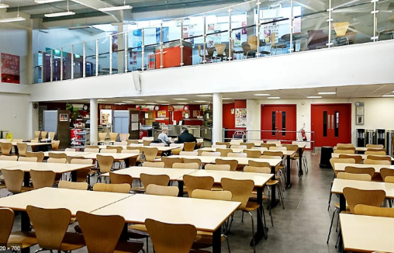

**Wednesday 10 July 2024 8:20am to 3:00pm**

**Thursday 11 July 2024 8:20am to 3:00pm**

**Friday 12 July 2024 8:20am to 3:00pm**

Year 6 students will be invited to spend three full days with us here at Jesmond Park Academy on 10, 11 and 12 July. The days will start at 8:30am (children to arrive for 8:20am) and finish at 3pm. Primary school uniform and trainers should be worn on this day and students should bring their own water/drink and we advise that you provide them with sunscreen.

The day visits to the school will involve sample lessons, a range of activities, and a tour of the school.

For the visits, you will need to make travel arrangements for your child to and from Jesmond Park Academy. We recommend that the children make the journey to and from school independently in preparation for September.

**Please note:**

* Your child will need to bring a packed lunch each day. However, a packed lunch will be provided for students who receive Free School Meals**. If your child is eligible for Free School Meals, please indicate their preference on the reply slip enclosed.**
* You child will need to wear trainers for the three transition days as they will be involved in PE activities on one of the days.
* They will also need to bring a reading book with them on all three days.