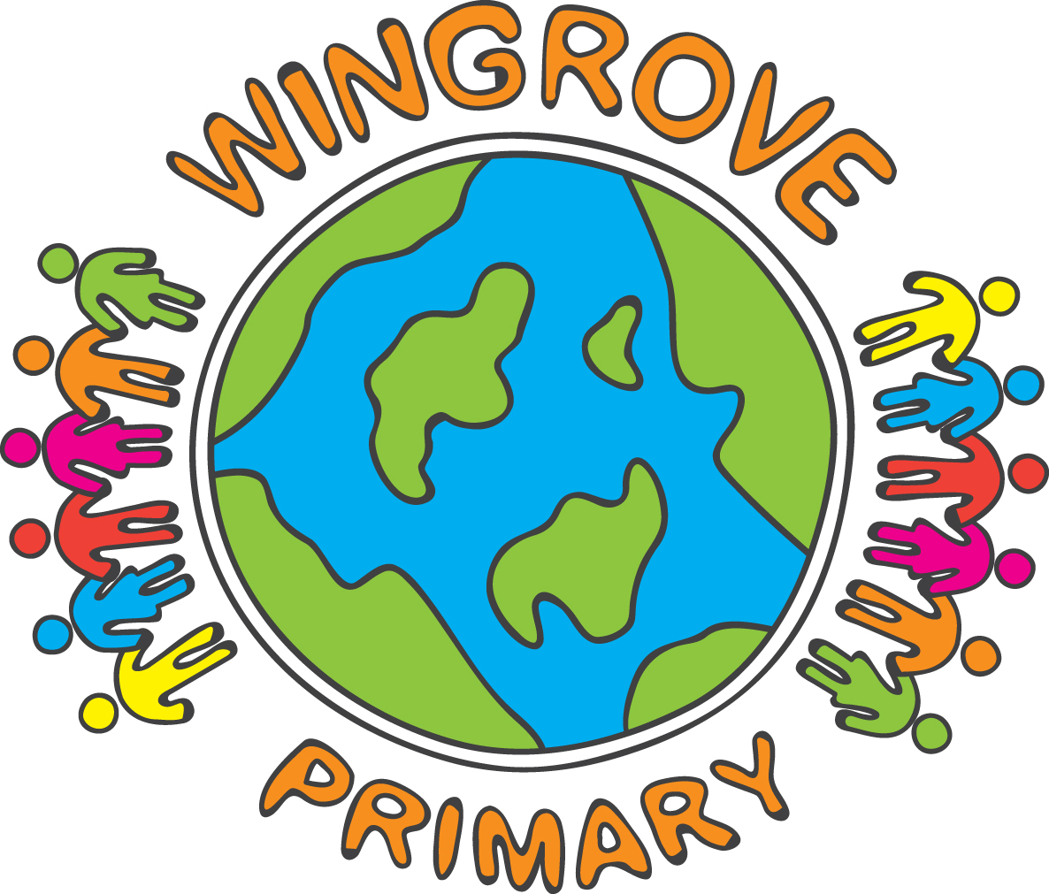

WINGROVE PRIMARY SCHOOL

Operating a halal kitchen

Christmas Lunch
Thursday 12th December

For your information - this is the menu for Christmas lunch, on Thursday 12th December.

Roast Chicken Breast or
Roast Quorn Fillet

With

Chicken or Vegetarian Sausage
Stuffing and gravy
Brussels Sprouts, Carrots and Sweetcorn
Roast Potatoes

Dessert
Vanilla Ice Cream with Mandarins
Or
Seasonal Festive Biscuit
Or
Fruit

Thank you.



