We are delighted that we will once again be running our popular Summer Safety Campaign this year. In previous years we have seen over 1600 children during the initiative weeks; who have taken part in fun awareness sessions covering fire, water, travel and beach safety just in time for the good weather. I am pleased to tell you that we will be running the Summer Safety Campaign again between 29th April – 10th May and 20th -24th May 2024.
Chief Fire Officer Peter Heath

email: lucy.fisher@twfire.gov.uk

Our Ref: LF/Summer23

Date: 30 January 2024

This programme is open to all of the Primary Schools in Tyne and Wear and schools can bring any year group. The cost for a session is £110. We run our sessions morning and afternoon, 10:00 -12:00 or 1:00 – 3:00 p.m. and we can take up to 60 children in one session.

Summer Safety is one of our most popular campaigns and we always have a high level of interest with sessions getting booked very quickly. To avoid disappointment please contact us early to make your booking.

If you would like to make a booking or have any queries please contact either myself or my colleagues on 0191 4441131, e-mail lucy.fisher@twfire.gov.uk

Please note late cancellations (less than 10 working days) or non-attendance to the centre will incur a charge of £90 to the school.

Risk Assessments and directions to SafetyWorks! can be found on our website www.safetyworks.org.uk

Yours sincerely

Lucy Fisher
Centre Manager
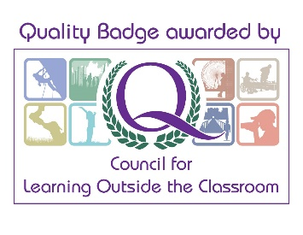
SafetyWorks!

SafetyWorks! West 15 Whickham View, Benwell Newcastle upon Tyne NE15 6UN
Telephone 0191 444 1130

