
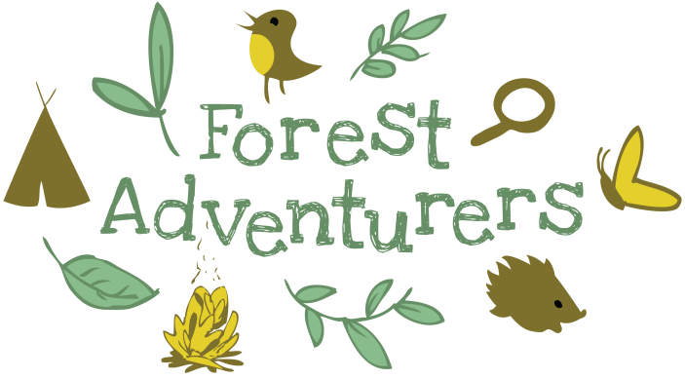

*** EASTER HOLIDAY CLUBS ***
Michelangelo’s, Ryton, 10-3pm

Wednesday 8th, Thursday 9th,
Wednesday 15th & Thursday 16th April

Order a delicious Italian takeaway to be delivered to the woods! (£35 per day with own food / £40 per day with food) Suitable for children from Reception age and upwards.
Activities can include campfire and s’mores, fire lighting, mud, sand and water play, outdoor crafts, mud kitchen, tools, hammocks, messy play, hill climbing and free time to explore.
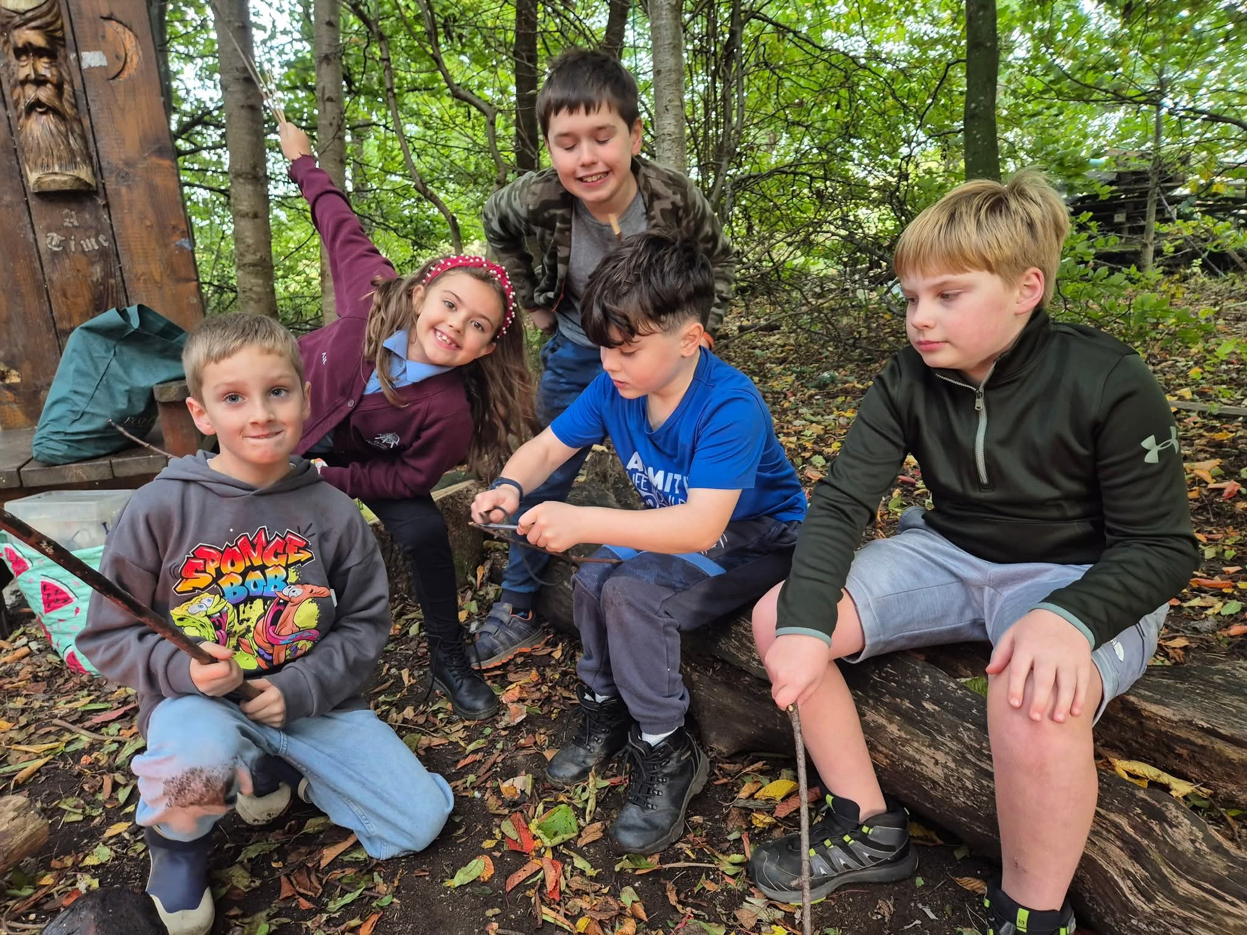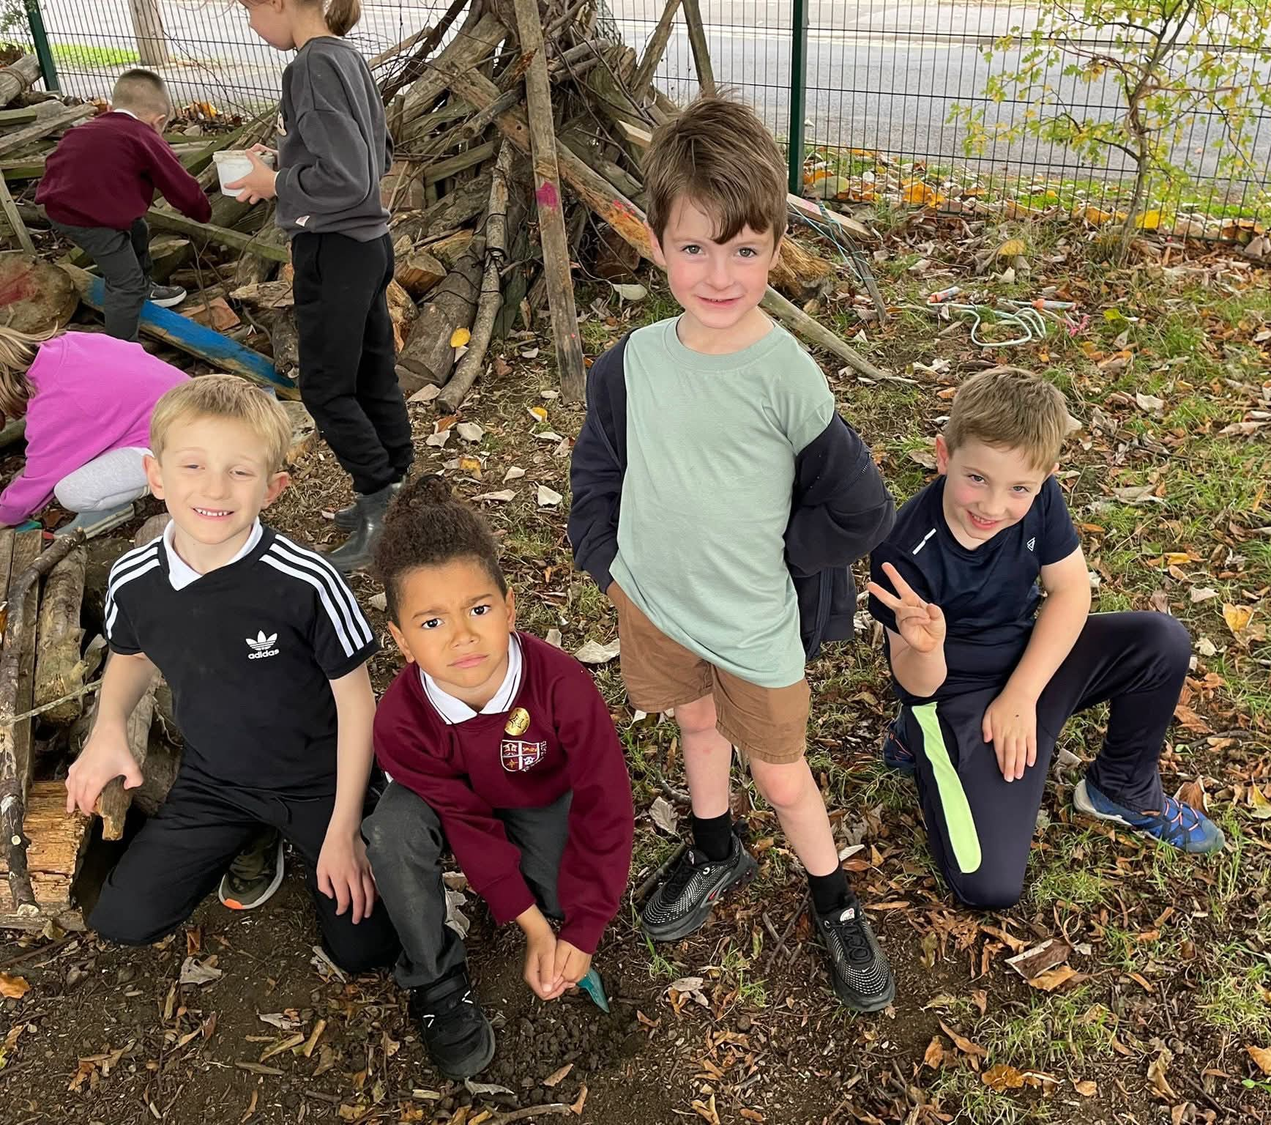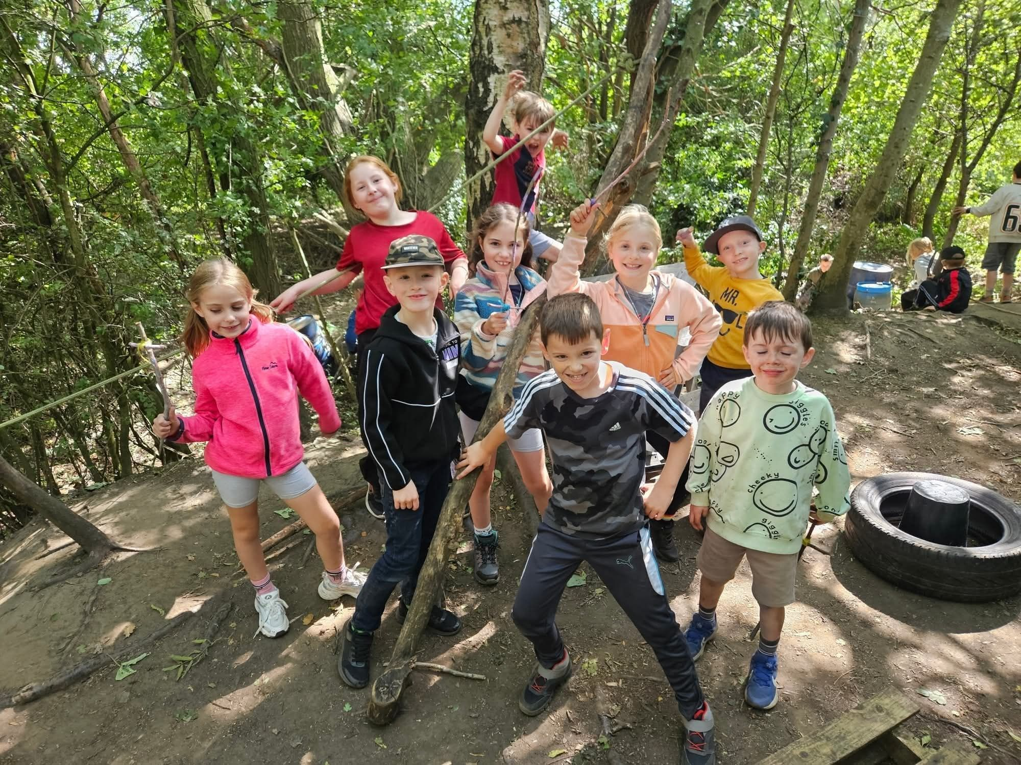
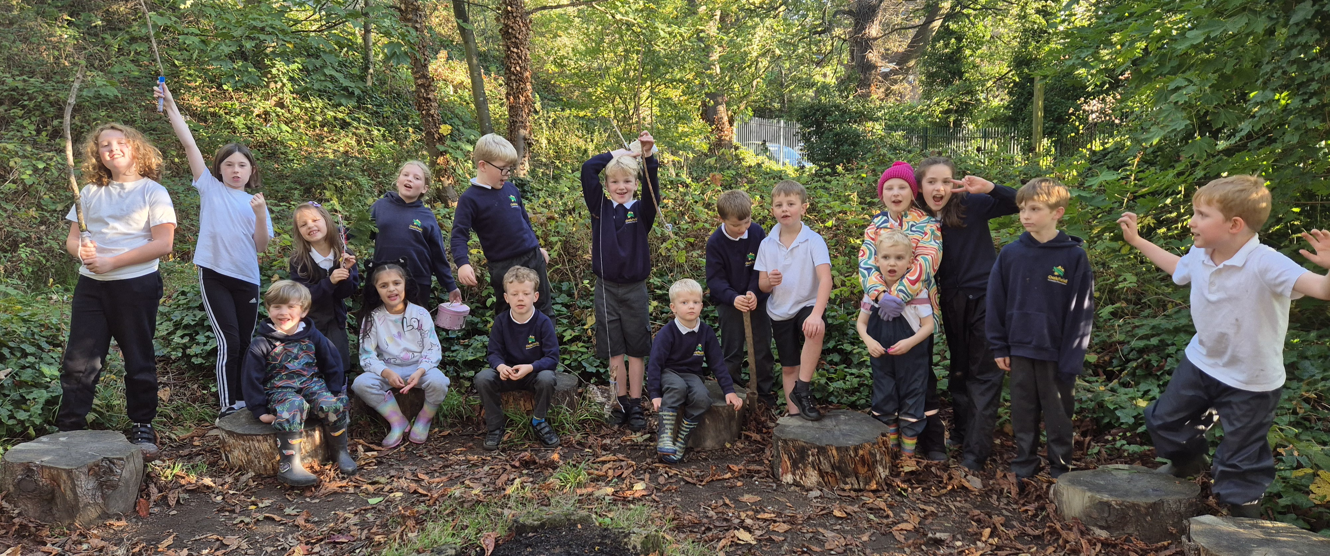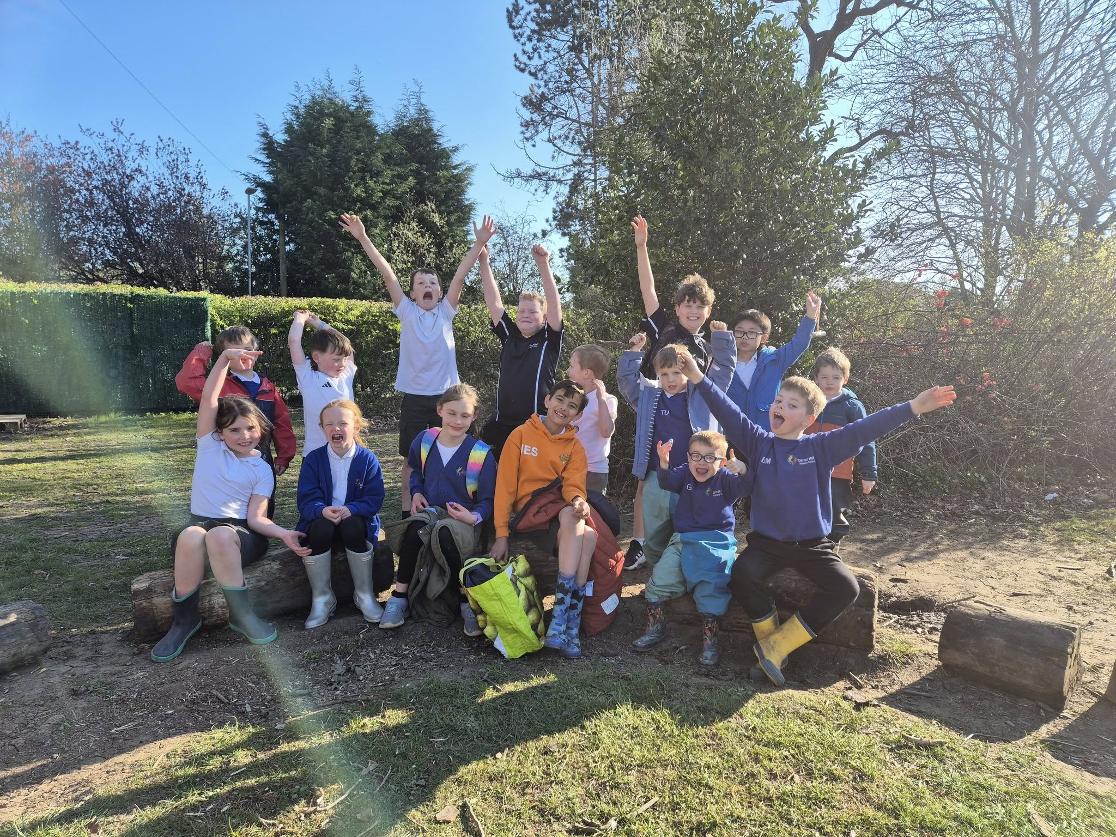
https://bookwhen.com/forestadventurers
suzanne@forestadventurers.co.uk
07711461409

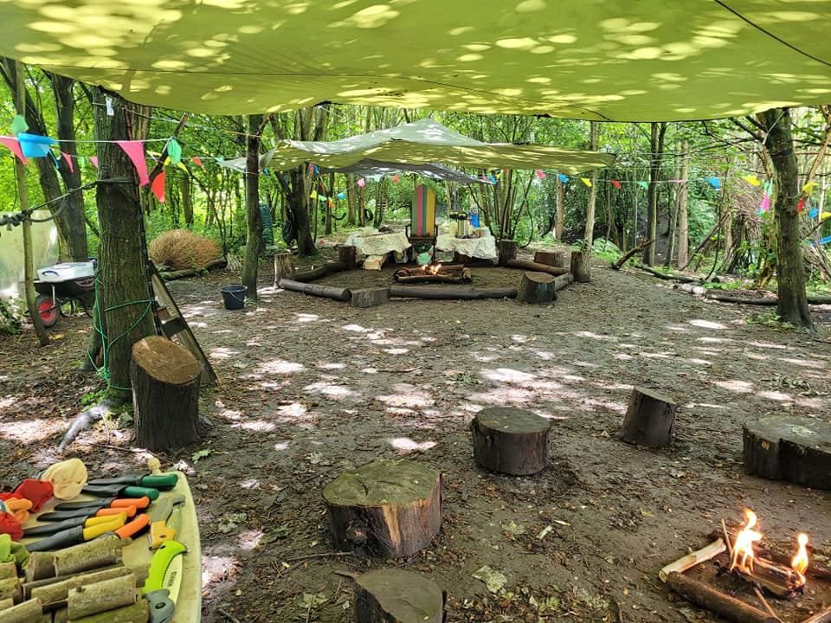




Contact us for more information on:

────

Corporate Events

────

Parent and Preschool Groups

────

After School Clubs

────

Birthday Parties

────

School Trips
────


