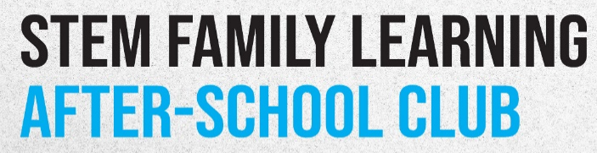
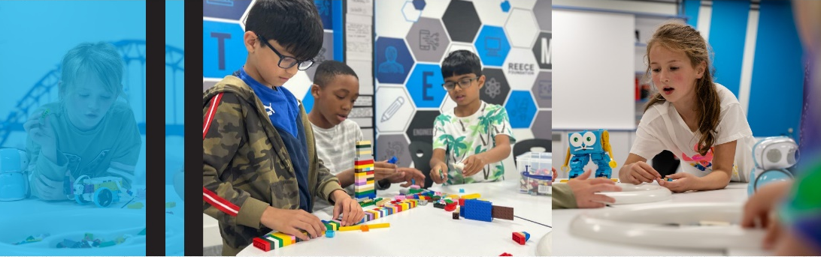
Dear Parent / Carer,
We are excited to invite you and your child to participate in a STEM Family Learning Club hosted by Newcastle United Foundation!
This after-school club is designed to bring families together to explore the exciting world of Science, Technology, Engineering and Mathematics through engaging, hands-on activities. Why? To inspire a love for STEM, foster collaboration and strengthen the parent-child bond through shared learning experiences.
- Children MUST be accompanied by an adult every session
- TIME: 3.30pm-4.15pm
- DATES: Weekly on Thursdays (18th, 25th June and 1st and 8th July) for 4 weeks
- LOCATION: Please arrive via the main entrance at Wingrove Primary School
No prior experience is needed - just a sense of curiosity and a willingness to have fun!
To attend, please complete the form below:
Wingrove Primary School – STEM Family Learning After-School Club Sessions

Full name………………………………………………….………………………………………………………………
Child’s name………………………………………………………………………Class………………………………
Phone………………………………………………………….Email……………………………………………………
Sign…………………………………………………………………………………………………………………………

